**Main factors associated with hiring at UN agencies**

**Technical Report**

**Prepared By:**

Yousof Hajhasan 20200551

Abdulrahman Melhem 20190006

Zaid Abdullah 20200284

Omar Qandil 20200071

Mohammed Morshid 20180605

Yazeed Khaleel 20200354

**Course Name**: Data Visualisation **Tutor Name:** Dr.Osama Abdelhay

**Table of Contents:**

**1. Abstract**

**2. Introduction**

**2.1 Overview**

**2.2 Data**

**3. Methodology**

**3.1 Concept**

**3.2 Data preparation**

**3.3 Exploratory data analysis**

**4. Results**

**4.1 Insights**

**5. Appendix**

**5.1 Figures**

**Abstract:**

The report aims to examine the factors that impact the hiring process of United Nations Agencies, by focusing on individuals from the roster in the UN's database. The study uses both qualitative and quantitative methods to analyze two datasets, "Recruitment" and "Roster", which comprises of 625 and 28,782 records respectively, to understand how the decision to hire or not is based on these factors. The report's goal is to find a relation between different variables that effect the hiring process. The report includes data preparation, exploratory data analysis, visualization and a calculation of probability of getting hired based on different variables. The results indicate that the number of hired applicants decreased in 2020 due to the impact of the Corona pandemic, Africa has the highest probability of being hired, and there is no significant difference in hiring probabilities between males and females.

**2. Introduction**

**2.1 Overview**

The United Nations Agencies have a hiring process that includes both internal and external advertising for job openings. There are two main pools of potential candidates for these positions: a roster of pre-approved individuals in the UN's database and external applicants who can apply directly through online forms. Our study aims to examine the factors that impact the hiring process and in particular, we will focus on individuals from the roster in the UN's database. We will analyze the data using both qualitative and quantitative methods to understand how the decision to hire or not is based on these factors. We will also conduct an exploratory data analysis of the provided dataset and prepare it for visualization to gain a deeper understanding of the data and identify potential factors affecting the hiring process. **2.2 Data**

Our research includes two datasets, namely "Recruitment" and "Roster." The first dataset, "Recruitment," comprises 625 records and 20 columns, each record representing individuals who have already been hired by UN agencies. The second dataset, "Roster," contains 28,782 records and 21 columns, and it comprises of candidates who have registered in the UN talent pool. Both datasets share common attributes, including "Applicant Number," "Gender," "Region," "Level," and "Account Status."

**3. Methodology**

**3.1 Concept**

The goal of our study is to investigate the correlation between various factors and their impact on the hiring process. To accomplish this, we will determine a methodology to extract the probability of an individual being hired. This will be done by dividing the number of hires by the total number of job applicants. Since we do not have any information regarding non-rostered applicants, our calculations will be based on rostered applicants only. This will allow us to calculate the possibilities based on different variables.

**3.2 Data preparation**

First of all, we dropped the duplicates from Recruitment and Roster datasets, Since we don’t want our results to be inaccurate.

Then we generated a dataframe from the recruitment dataframe where we got only the rostered applicants. After that we dropped the unneeded columns.

**3.3 Exploratory**

In (Figure 1), we grouped data by selection year to observe changes in the number of hired applicants over time. Figure 2 shows the distribution percentage of each Job Network over each Level, grouped by Levels and Job Networks. Figure 3 examines the relationship between level and age, while Figures 4-7 analyze the probability of being hired in relation to region, gender, fluent languages, and account status, to calculate probability, firstly we need to add new column that have the percentage of being hired, to calculate this percentage we need to count the number of recruited applicant from a specific value in each variable over the whole number of job applicants in the same region from Roster dataframe.

The last figure, Figure 8, compares the number of hired applicants and probability of being hired by nationality.

**Results:**

**4.1 insights**

indicate that the number of hired applicants decreased in 2020, possibly due to the impact of the Corona pandemic. Additionally, we observed that SCINET and SAFETYNET are not found at the P-5 level, and that Africa has the highest probability of being hired from the roster. We also found that there is no significant difference in hiring probabilities between males and females, and that an increase in fluent languages increases the probability of being hired. Furthermore, internal applicants were found to have 2.5 times higher chances of being hired compared to external applicants. Lastly, we found that while America had the highest number of hired applicants, Germany had the highest probability of being hired.

**Appendix:**

**5.1 Figures:**

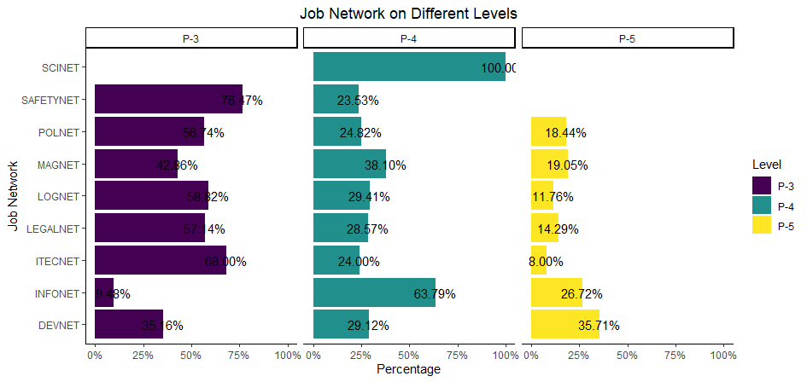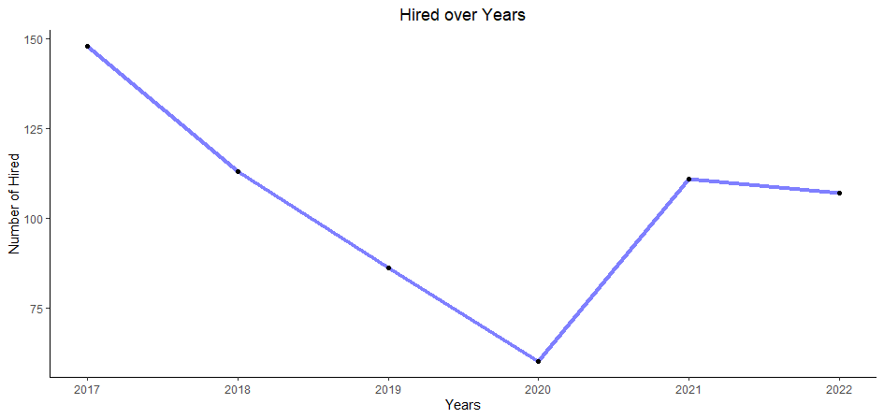

Figure 1

Figure 2



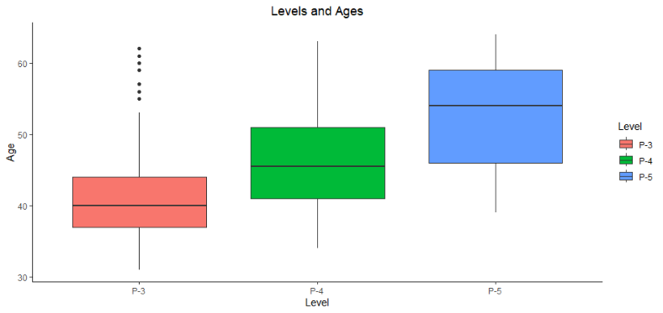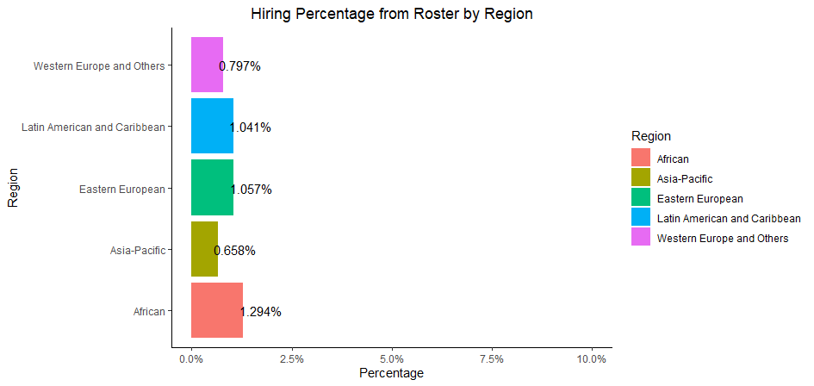

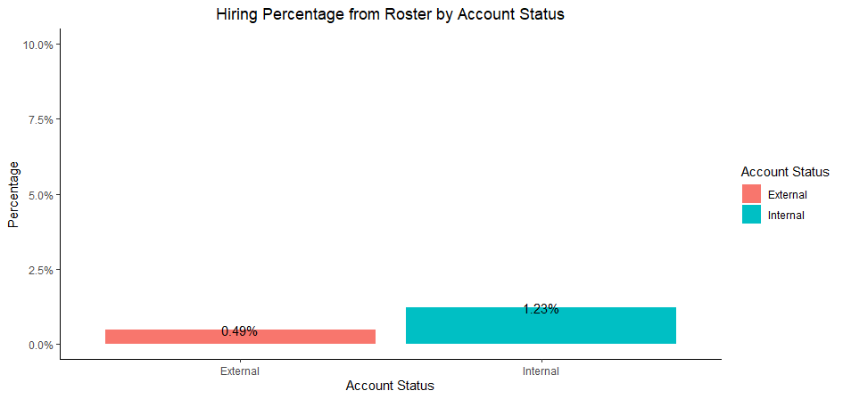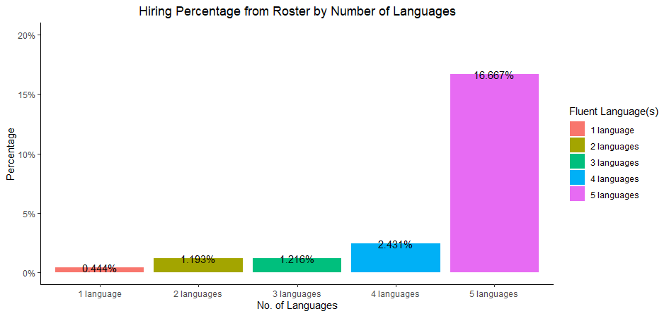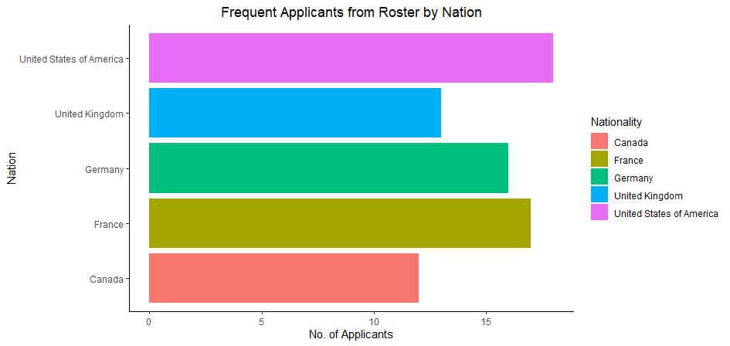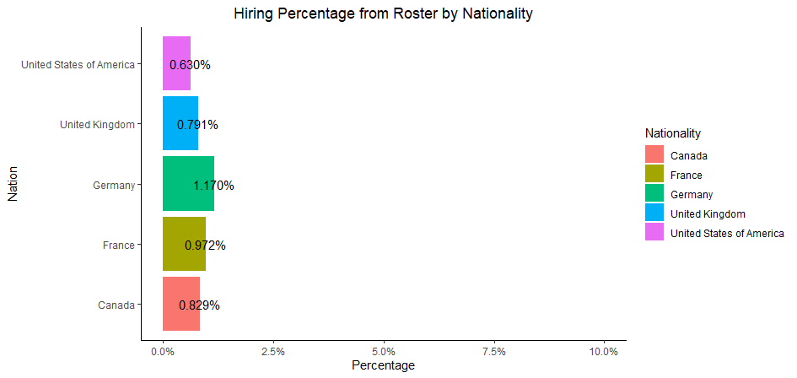

Figure 8

Figure 7

Figure 3

Figure 4

Figure 6

Figure 5